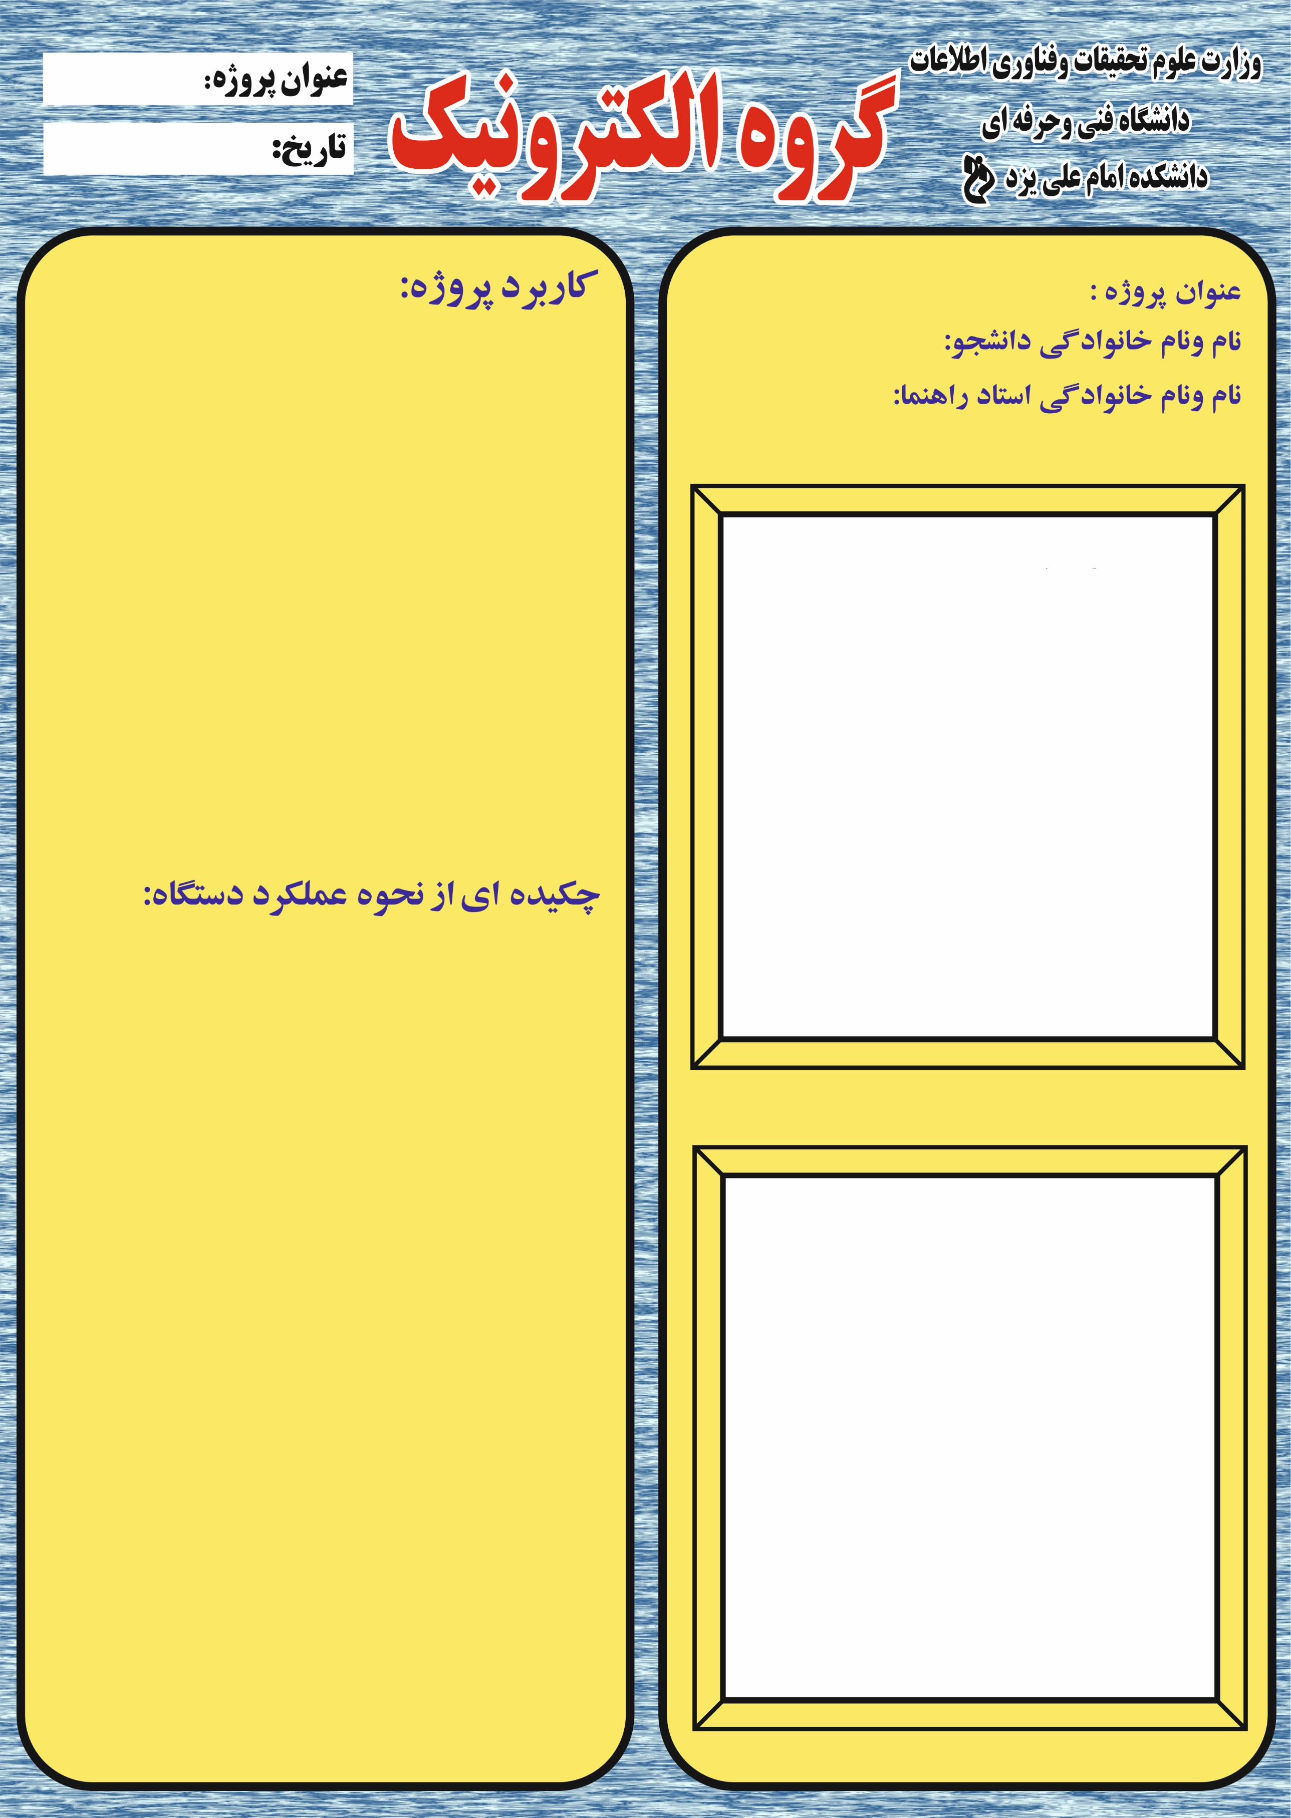

**.........................**

**.........................**

**.........................**

**.........................**

**.........................**

**.........................**

**.........................**

**.........................**

**.........................**

**.........................**

**.........................**

**.........................**

**.........................**

**.........................**

**.........................**

**.........................**

**.........................**

**.........................**

**.........................**

**.........................**

**…………………….**

**تصویر پروژه ساخته شده**

**مدار پروژه**

**…………………….**

**…………………….**

**…………………….**

**……………….**